Creative Technologies Project: Research Report

Abstract

The field of Artificial Intelligence (A.I.), is an area of much personal intrigue and passion, it is also one of the most visible and heavily scrutinised features within modern games. Heretofore no major piece of software has been published which utilises A.I. within a 3D tiled environment. As such, this report encapsulates research in the area of “Turn based strategy AI within 3D space”. The main outcome of the project is to have fully investigated as to the practicality and/or possibility of having turn based strategy artificial intelligence operate within a 3D environment. However, another outcome of the project, will be the advancement of the field of A.I. for games, the fact of there being no other examples of said A.I. behavior allows for the opportunity to spearhead a probe to explore new ground for this field.
Sam Endean
Department of Computer Science and Creative Technology
University of the West of England
Coldharbour Lane
Bristol, UK
sam2-endean@uwe.ac.uk

Submitted 10/12/2015

Author Keywords
Artificial Intelligence; Weak Artificial intelligence; 3D movement; Real time strategy; Pathfinding; Goal orientated action planning.

Introduction
The initial aim of this A.I. project is to represent the system through a turn based 3D space battle between two teams. The context of the behavior will be that of ship to ship space combat, with one or both sides being controlled wholly by A.I. seeking to conquer and destroy the enemy. The entire space will be comprised of 3D space filling volumes, these will act as traditional turn based strategy tiles, but instead allowing for movement in all 3 dimensions of space. The questions which drive the investigation are as follows:
- What effect, if any, will the framework of a 3D environment have on the performance of pathfinding and world-contextual reasoning? The exploration of this is done through implementation and iterative development.
- How appropriate is the application of an A* pathfinding algorithm within a turn based/tiled environment in contrast to other pathfinding methods? This is examined through repeated testing throughout the iterative development cycle.
- What benefits, if any, does the application of the “Goal orientated action planning” model hold over other reasoning methods when applied to a turn based strategy environment? The determination of this question shall be through examining the visible output of the system, looking for evidence of reasoning and pseudo-intelligence via testing.

Research methods
On the whole research has been carried out through secondary methods, however an instance of primary research accidentally came to fruition.
The reason for the use of secondary research methods is solely due to the nature of the project. The heart of the project lies in applying a version of pre-existing programming techniques into a new framework in order to investigate how appropriate such a move would be. As such there appears to be no primary research to be done whatsoever, as the project is an investigatory form of primary research in and of itself.
The form in which most of said secondary research takes is that of qualitative research from published works of text. The reason for the execution of qualitative research over quantitative is because using quantitative research for a project such as this would be completely unsuitable. This is because the project is involved primarily on constructing a specific system and is not focused on mass testing (Although testing will of course take place.) However in terms of knowledge acquisition with the system’s construction in mind the research carried out must be incredibly clear and accurate. The closest thing to quantitative research carried out for this project is in the form of considering several different techniques for specific problems and weighing up their pros and cons.
Said works of text are professional pieces by highly experienced authors. For the most part, these works focus on a single technique at a time, going into depth about their functioning, their pros, their cons, and then comparing several of them by applying them to a similar problem. These pieces are perfect for this project, as from a single work, details on many different A.I. techniques can be researched, as such the core source of research for the project is Artificial Intelligence for games (Millington et al, 2009). However this is not to say that other reading has not been taking place around this, as realistically, no single source will ever be completely comprehensive/ exhaustive.
Sources other than text books have been used for research too, academic papers also have a wealth of knowledge to be tapped. Similar to text books, papers will address programming techniques and other such methodologies, however text books and papers will often differ from one another in terms of depth. Text books will address several techniques within a chapter, conveying enough information to grant knowledge to the consumer, whereas a paper often focusses on one particular technique, or the application thereof, of and goes into more depth on said specific topic. A perfect example is the MIT (Massachusetts Institute of Technology) paper which goes into detail about “Three States and a Plan: The A.I. of F.E.A.R.” (Orkin, 2006).

Research findings

3D space and tiling:
At first glance, the expansion into 3D sounds easy, one may state that “3D is just 2D but taken further”, to which one would be partially correct, yet rather disingenuous. S.Jadhav, the Co-Founder and CEO at the Centre for Computational Technologies (CCTech) wrote an internet post recalling his professor’s statements: “Remember, 3D is not just 1.5 times of 2D, its lots more”. This is a very good point, as it is easy to think of 3D as a small extension of 2D, however Jadhav makes the point using a voxel grid as an example: a hypothetical 2D voxel grid composed of squares to be 1000*1000 would take 24 megabytes of data to store, whereas a 3D grid using 3D versions of the same shape (cubes) would be 1000*1000*1000 and so would require 24 Gigabytes of data to store. (Jadhav, 2014). This succeeds in demonstrating that without some significant data management a 3D system may become unwieldy and require an inordinate amount of space to store.
The solutions to problems are also very different once transposed into 3D as well, in such that calculating whether something is within a certain area of space is very simple when working in 2D, as everything is on one, flat plane. However in 3D this is somewhat subject to combinatorial explosion, whereas other such problems require an entirely new way of thinking in order to be solved.
Many of these issues will manifest themselves within the system as a reduction in performance due to such calculations having to be done every time an agent moves (usually every single frame), proving to be very costly to a computer and will usually result in severe drops in performance/framerate. However, due to the nature of the framework of the system, that of turn based strategy, the computer will have much more leeway in terms of having to make decisions within an acceptable amount of time. This means that the biggest issue with adding a third dimension shall not come from performance (provided it is within an acceptable limit), but instead in the form of taking time to apply the somewhat more complex algorithms and calculations to the game world. The mitigation of such issues has been done through research into 3D based mathematics in order to top up prior knowledge appropriately.
Earlier in this paper was the mention of an accidental piece of primary research taking place. This occurred when creating the world using unity, this entailed creating the shape desired for the tiles of the world (the Dodecahedron). Upon cloning the first dodecahedron, nothing seemed out of the ordinary, as seen in Figure 1.

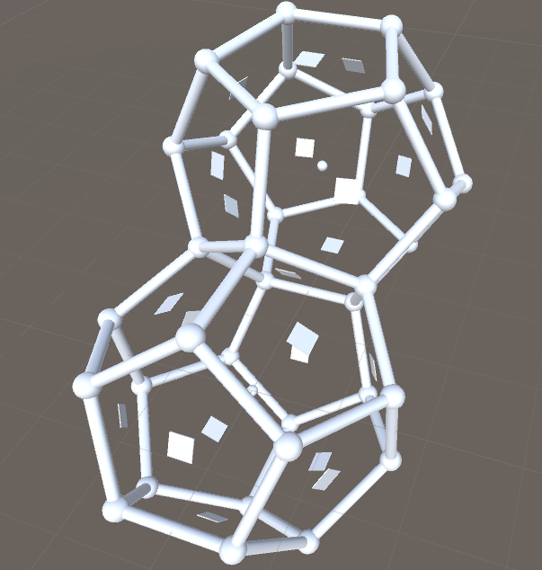
Figure 1. The original Dodecahedron, cloned and repositioned so as the two shapes connect perfectly.
When a second clone was created and the process repeated, as in figure 2, it was abundantly clear that Dodecahedrons do not actually tile space in 3D! This is because “The Dihedral angle (between two faces) is about 116 degrees… a value less than 360/3 = 120 degrees!” (Berger, 2010, Pg. 633). This discovery, whilst maddening, was extremely important to the project and to all other research: It showed that previous research had not been done thoroughly enough, which had caused misunderstandings and incorrect assumptions.
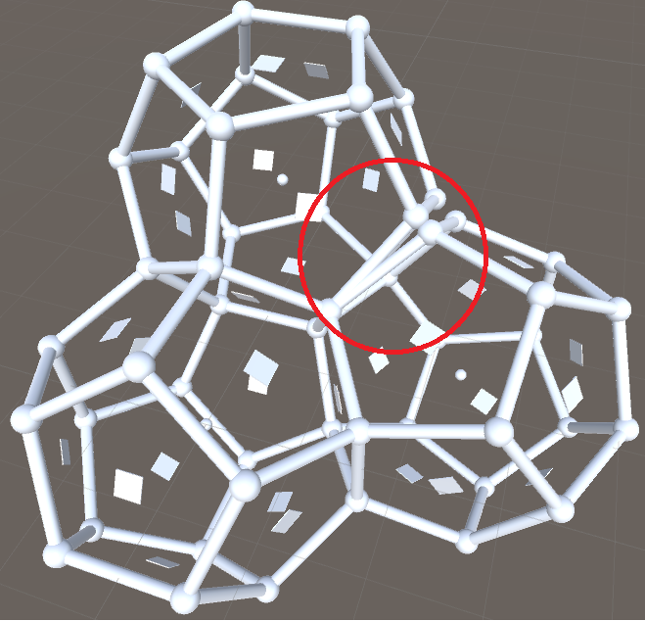
Figure 2. A second clone has been created and repositioned. The circle highlights that the clones will not perfectly tile with each other. Thus demonstrating Dodecahedron’s inability to tessellate.
Of course, the initial result of this was that a new shape had to be found in order to still have a wide choice of directions, like a dodecahedron, although it would also need tile perfectly in 3D space. The shape found is the truncated Octahedron, as it will tile space in 3D whilst still providing more choice/variation in terms of movement directions than that of a generic cube.

Pathfinding:
Having an established knowledge of pathfinding through Dijkstra’s algorithm, the A* algorithm was a natural progression. Both are used through application to “Directed non-negative weighted graphs” (Millington et al, 2009, Pg. 11), graphs of movement nodes, all connected with non-negative weighted connections, meaning they cost a specific amount to traverse.
Dijkstra’s algorithm, despite its pathfinding uses, was actually created as a solution to the ‘Shortest path’ problem. The shortest path problem is the attempt to discern the shortest distance to reach EACH node from any start node. “Dijkstra works by spreading out from the start node along its connections. As it spreads out to more distant nodes it keeps a record of the direction it came from, eventually, it will reach the goal node and can follow the arrows back to its starting point to generate a complete route. Because of the way Dijkstra regulates the spreading process, it guarantees that the chalk arrows always point back along the shortest route to the start.” (Millington et al, 2009, pg. 206)
Dijkstra’s is always guaranteed to find the optimal path to the goal node from the route, however the method makes it wasteful, as it explores many irrelevant nodes. As such the algorithm can be described as accurate but not very efficient.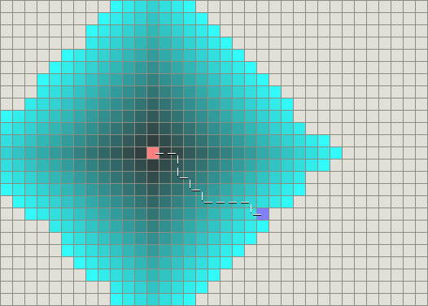 Figure 3. Dijkstra’s algorithm applied to pathfinding. The start node is in the center, whilst the explored nodes are blue, and the goal node is. This demonstrates inefficiency in Dijkstra’s algorithm: many irrelevant nodes are considered. (Patel, A. 2015)
“Dijkstra’s algorithm searches by minimising the cost of the path so far. It can be improved significantly by taking into account, when putting nodes on the frontier, an estimate of the cost to the target from each node under consideration. This estimate is usually referred to as the heuristic, and the name given to the algorithm that uses this method of heuristically directed search is A*” (Buckland, 2005, pg. 241). This is the essence of A*, an evolution of Dijkstra’s algorithm to include a heuristic function: An estimation of the distance from the current node to the target node. (Often done using the Euclidian distance, a straight-line to the goal or often the “Manhattan distance between two nodes: the sum of the displacement in tiles vertically and horizontally.”) (Buckland, 2005, pg. 246).
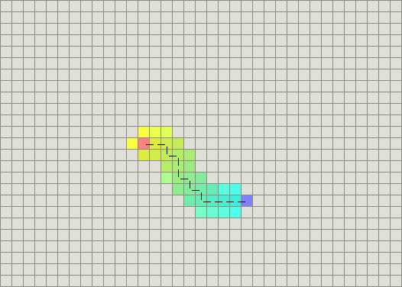 Figure 4. A* algorithm applied to a similar problem to Figure 1. The orange center is the start, whilst the purple square, the goal. This demonstrates the extreme increase in efficiency from the behavior of Dijkstra’s algorithm due as less nodes are “wasted” as with Dijkstra’s. (Patel, A. 2015)
An advantage of A* is that the heuristic causes a reduction in computational time, forming a directed search towards the goal in contrast to Dijkstra’s greedy blind searching.
However “The quality of A*'s search depends on the quality of the heuristic estimate... If h is very close to the true cost of the remaining path, its efficiency will be high; on the other hand, if it is too low, its efficiency gets very bad.” (Stout, 2015), so if the heuristic is set to 0, the algorithm behaves identically to Dijkstra’s algorithm, wasting nodes.
One more con of using the A* algorithm is that a very long path can push the memory requirements of a computer to unacceptable levels. As such, a third form of pathfinding was considered, Hierarchical pathfinding. Hierarchical pathfinding specialises in using localised A* algorithms in order to construct a path over very large distances. For example: To reach their goal (the hotel), someone must leave their office, catch a flight, then take a cab to their hotel. This path would be very expensive to do all at once, so the system will have its first layer of reasoning be abstract. Each part is calculated as it occurs, so initially it will construct a plan for leaving the office. Once out of the office, a plan for the next part of the journey is calculated and so on. (Millington et al, 2009, pg. 256)
Hierarchical pathfinding solves the problem of A*’s memory requirements however criticism could be raised by the fact that the connections between these optimal groups may not result in the best path, instead in local optima.
As for this system the method to be used is the A* algorithm. The reason for not using Dijkstra’s algorithm was in order to not only make the system more efficient, but to add the occasional appearance of human error into the system, making it more believable. Moreover the reason for choosing A* over Hierarchical pathfinding is that hierarchical pathfinding will most likely not be necessary due to the size of the world being smaller than those for which Hierarchical pathfinding was intended. This means that the complexity of implementing Hierarchical pathfinding is not quite warranted by the size of this project.

A.I. architecture techniques:
The most ubiquitous pattern of behavior within a weak A.I. system is that of an FSM (Finite state machine). An FSM is formed of states and transitions, with each having hard-coded transitions.
FSMs have the advantage of being specifically defined in their behavior and therefor easy to debug, however with more complex situations/considerations, the FSM can become very unwieldy when it comes to all of the different transitions for the states.
Were this project a task that was not focused on A.I. behavior, FSM would have been a suitable choice of A.I. architecture. However for this system, an FSM is too brutally straight forward, meaning that in order to obtain the behaviors desired, it would become majorly bloated. Not only this, but any previously unforeseen states and transitions that need to be added will require all other states and transitions to be reconsidered.
Another issue of FSM behavior is that the behavior is purely reactionary, similar to that of animalistic instincts, whereas the ideal perception of the final system would that it behaves with more agency towards an overall goal.
As such, another major pattern of A.I. behavior explored was that of Goal Orientated Action Planning (GOAP), or Goal Orientated Behavior. GOAP is a technique used which frees the A.I. and allows them to have more agency with their actions. Goal orientated planning is very similar to the STRIPS system developed in the 1970s, (Jackson, 1999, pg.42): On a base level the system maintains a list of goals, the system is also equipped with the formulae to work on reaching said goal. The priority of the goals is weighted, and as such the character will always carry out the goal with the highest priority, meaning “the character is always capable of independent action” (Millington et al, 2009, pg. 402).
Orkin describes how these plans look in terms op picking suitable functions, in this case the plan “Involves first going to the generator and turning it on, and then using the laser. The plan might look like:
GotoPoint(generator)
ActivateObject(generator) GotoPoint(laser) ActivateObject(laser) MountedAttack(laser)
The GOAP decision-making architecture allows character X to handle dependencies that may not have been anticipated at the time of the behavior development.” (Orkin, 2003, Pg. 4).
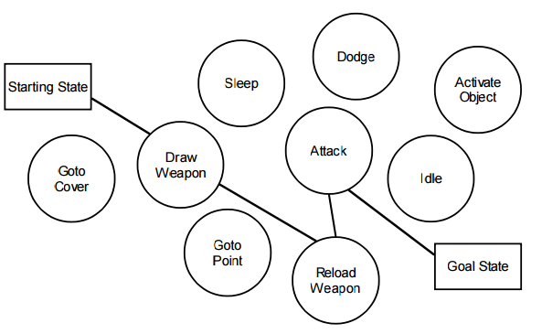Figure 5. This demonstrates the planning process as the system uses the available actions in order to formulate a plan that will reach the goal state. (Orkin, 2003)
An example of the technique was in F.E.A.R. by Monolith Productions. In a conference paper, Orkin states the “Three benefits of a planning system, the first benefit is the ability to decouple goals and actions, to allow different types of characters to satisfy goals in different ways… The second benefit of a planning system is facilitation of layering multiple simple behaviors to produce complex observable behavior… The third benefit is empowering characters with dynamic problem solving abilities.” (2006) These show that GOAP not only improves the behavioral pattern of agents in the system, but makes adding new goals and actions relatively simple, in contrast to FSMs, which can prove tricky if newly considered states must be added to an agent. Furthermore “An FSM tells the A.I exactly how to behave in every situation. A planning system tells the A.I. what his goals and actions are, and lets the A.I. decide how to sequence the actions to satisfy goals.” (Orkin, 2006)
With all of the strengths of GOAP, it is not perfect. A GOAP system can be hard to balance in terms of weighting individual goals. Furthermore GOAP systems require significantly more programming effort to create than an FSM.
For this project, a GOAP system seems the most suitable as it gives agents more control over their own actions and can lead to impressive emergent behavior (as seen with flanking A.I. in F.E.A.R). This will be the center of the entire A.I. engine as it will be the most complex part to implement.

Conclusion and recommendations
Having set out to answer the initial research questions above, further exploration of lead to new considerations.
Firstly, “The best AI programmers are those who can use a very simple technique to give the illusion of complexity” (Millington et al, 2009, pg. 11), good A.I. does not have to always use the most complex algorithm. Moreover, Togelius, associate professor at New York University, states: “I have the feeling that when developers make the effort to put really sophisticated AI into a game, gamers frequently just don't notice (see e.g. Forza). Conversely, games that are lauded for their fantastic AI are sometimes based on very simple algorithms (e.g. Halo 1).” (Togelius, 2007).
These points effected the planning of this system through the reminder that systems should always be fit for purpose: over engineering is as much a sin as the opposite. This meant that deeper considerations were given to the use of GOAP, however after review GOAP has been shown to be an effective reasoning process, simply in need of precise balancing, the fact that F.E.A.R used the technique to such success is very encouraging.
The biggest impact on the conduct of research and planning was the discovery that dodecahedrons will not tessellate in 3D. It meant that all previous research had to be double checked in order to reassert validity and also meant for much more careful research being conducted in order to reinforce the understanding of implementations and concepts.
In conclusion, the system shall now be composed of tiled world of truncated-octahedrons, utilising GOAP as the core A.I. architecture, with an A* algorithm performing pathfinding for the system.
Moving forward, the following lessons shall be in mind: Don’t needlessly overcomplicate the workings of the A.I. instead keep it fit for purpose. Secondly, double and triple check all findings for misunderstandings or inconsistencies. These lessons will help the development of any future project by the fact that they are applicable to most all projects, regardless of medium.
(Wordcount: 3252)

References
Berger, M. (2010) Geometry Revealed: A Jacob’s ladder to Modern Higher Geometry. New York: Springer-Verlag

Buckland, M. (2005) Programming Game AI by example. Plano: Wordware publishing inc.

Jackson, P. (1999) Introduction to Expert Systems. 3rd ed. Addison Wesley Longman Limited.

Jadhav, S. (2014) 3D is not 1.5 times 2D. Sandip Jadhav [Blog]. 06 May 2014. Available from: https://www.linkedin.com/pulse/20140506202304-14648565-3d-is-not-1-5-times-2d [Accessed 05 October 2015].

Millington, I. Funge, J. (2009) Artificial Intelligence for Games. 2nd ed. Burlington: Morgan Kaufmann publishing.

Orkin, J. (2003) Applying Goal-Oriented Action Planning to Games. AI Game Programming Wisdom 2, 217-228. Charles River Media.

Orkin, J. (2006) Three States and a Plan: the A.I of F.E.A.R. Games Developers Conference 2006. Monolith Productions / M.I.T. Media Lab, Cognitive Machines Group.

Patel, A. (2015), Dijkstra’s algorithm and best-first search. Available from: http://theory.stanford.edu/~amitp/GameProgramming/AStarComparison.html [Accessed 27 October 2015].

Stout, B. (2015) Smart Move: Intelligent Path-Finding. Available from: http://www.gamasutra.com/view/feature/3317/smart_move_intelligent?print=1 [Accessed 03 November 2015].

Togelius, J. (2007) Most impressive Game A.I.? Better living through algorithms [Blog]. 22 March. Available from: http://togelius.blogspot.co.uk/2007/03/most-impressive-game-ai.html [Accessed 20 October 2015].

Bibliography
Cheng, F. (2011) Multi-Tier AI and Behaviour Tree for RTS Games [online slideshow presentation]. Available from: https://chengfrank.files.wordpress.com/2011/12/multi-tier-ai-and-behavior-tree-for-rts-games1.pdf [Accessed 03/10/2015].
Kolodner, J. (1993) Case-Based Reasoning. San Mateo: Morgan Kaufmann publishing.

Unity Technologies. (2015) Unity answers. Available from: http://answers.unity3d.com/ [Accessed 13/10/2015].

Unity Technologies. (2015) Unity manual. Available from: http://docs.unity3d.com/Manual/index.html [Accessed 13/10/2015].
Weisstein, E W. (Unknown) Space-Filling Polyhedron. Available from: http://mathworld.wolfram.com/Space-FillingPolyhedron.html [Accessed 29 October 2015].

Appendixes:
Appendix A.
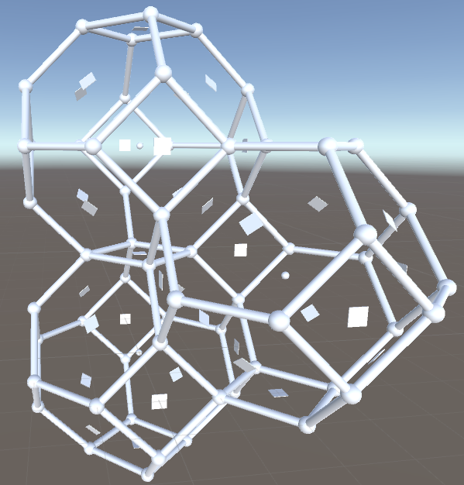
Figure 6. This shows the same rough test as seen in figures 1 and 2, but this time with a truncated octahedron. As shown, the truncated Octahedron will pack space perfectly, whilst still providing a wide range of directions in which to move to/from each volume.
Appendix B.
Once the heuristic of the node to be considered has been calculated, it is then added to the total cost of reaching said node. These together form the equation: F = G + H (Buckland, 2005, pg. 246) G is the distance to the node thus far, H is the heuristic estimation to the goal node, and F is the final weight of reaching said node.

Appendix C.
In reference to the varying heuristics of the A* algorithm, therein lay a very interesting conundrum: Would the system use an ‘inadmissible’ (overestimating) heuristic and accept sub-optimal paths, or better paths and underestimate? Millington et al state that “A game isn’t about optimum accuracy; it’s about believability” (2009, pg. 232). To this, there has to be agreement, a system that slightly overestimates the heuristic would be ideal, as it would still produce good paths, yet they would deviate from the optimal route just enough to appear as human navigational error. This could also be into difficulty if desired, Different difficulty settings, in which the heuristic function would be calculated in such a way to be more optimal (along with other calculations doing such), this will not hugely impact playability or performance as mentioned above and would increase the difficulty of an opponent, if they could always reach their destination in the optimal time.
Appendix D.
GOAP also allows for the inclusion of a simple multi-tiered A.I. system with a manager giving commands to the individual agents, and agents being able to refuse the commands if needs be. This system would be nearly impossible to do with an FSM, as the A.I. behaviors would end up being too unstable in terms of conflicting orders from the manager and its own internal FSM or the system would be too rigid and every command would be undertaken without question, essentially destroying the point of implementing a multi-tiered system in the first place.

